**Frenzy**

**Team 01**

|  |
| --- |
| **Team Members** |
| Ashwin Hariharan |
| Ankur Palav |
| Arpan Badeka |
| Rishabh Sharma |
| Sailee Rane |
| Jheel Somaiya |

**12/5/16**

# Version History

| Date | Author | Version | Changes made | Rationale |
| --- | --- | --- | --- | --- |
| 10/08/16 | SR | 1.0 | * Introduction, Shared Vision and System Transformation added. | * OCD draft before presentation. |
| 10/17/2016 | SR | 1.1 | * Modified the program model, benefit chain diagram, system boundary diagram, business work flow diagram, element relationship diagram, organizational goals. | * FC package |
| 12/5/16 | SR | 1.2 | * Modified program model, benefit Chain Diagram, system boundary diagram * Improved formatting | * Completed after reviewing feedback of FCP |

# Table of Contents

Operational Concept Description (OCD) i

Version History ii

Table of Contents iii

Table of Tables iv

Table of Figures v

1. Introduction 1

1.1 Purpose of the OCD 1

1.2 Status of the OCD 1

2. Shared Vision 2

2.1 Benefits Chain 3

2.2 System Capability Description 4

2.3 System Boundary and Environment 5

3. System Transformation 6

3.1 Information on Current System 6

3.2 System Objectives, Constraints and Priorities 6

3.3 Proposed New Operational Concept 10

3.4 Organizational and Operational Implications 12

# Table of Tables

Table 1: The Program Model 2

Table 3: Relation to Current System 9

# Table of Figures

Figure 1: Benefits Chain Diagram **Error! Bookmark not defined.**

Figure 2: System Boundary and Environment Diagram **Error! Bookmark not defined.**

Figure 3: Current Business Workflow **Error! Bookmark not defined.**

Figure 4: Element Relationship Diagram 10

Figure 5: Business Workflows Diagram **Error! Bookmark not defined.**

### Introduction

#### Purpose of the OCD

The purpose of this OCD document is to give an in-depth detail of the shared visions and goals of the stakeholders for the Frenzy web application. The success-critical stakeholders for the project are James Chang, the project owner, the users of the Frenzy website and Team 1 as the developers of the system.

#### Status of the OCD

The status of the OCD is currently under development version number 1.0. All the OCD main sections have been completed according to the Foundation Commitment Package requirements.

### Shared Vision

Our vision, in this project, is to improve the user experience by redesigning the website and adding more functionalities to the existing system. Frenzy website is an initiative towards turning digital media into visual store fronts.

Table : The Program Model

|  |  |  |  |
| --- | --- | --- | --- |
| **Assumptions** (Under what *Business* *assumptions* will this *‘model’* be true)   * People are willing to buy the items posted on fashion blogging site. * People like to buy the clothes that celebs wear. | | | |
| **Stakeholders** (Who is accountable for the initiatives) | **Initiatives**  (What to do to realize benefits) | **Value Propositions**  (Benefits i.e Why) | **Beneficiaries**  (Who derives value) |
| * Publisher * Retailer * Customer * Maintainer * Developer * Client | * Post articles on their blogs * Access to API’s, database, payment system * Exposure to latest trends and buying the available items * Maintains existing and new system functionality * Developing the front end and adding functionality * Outreach bloggers and retailers | * Easy access to Fashion blogging website * Benefit to users from increased efficiency of purchase * Automated content monetization * Increased market channel for retailers | * Customer * Client * Retailer * Publisher |

**Legend:**

Initiatives that need to be undertaken to help beneficiaries **derive value** from the expected benefits/value propositions

Initiatives that need to be undertaken to help **deliver value** to the beneficiaries (i.e. “how” will the benefits reach the beneficiaries?)



#### Benefits Chain

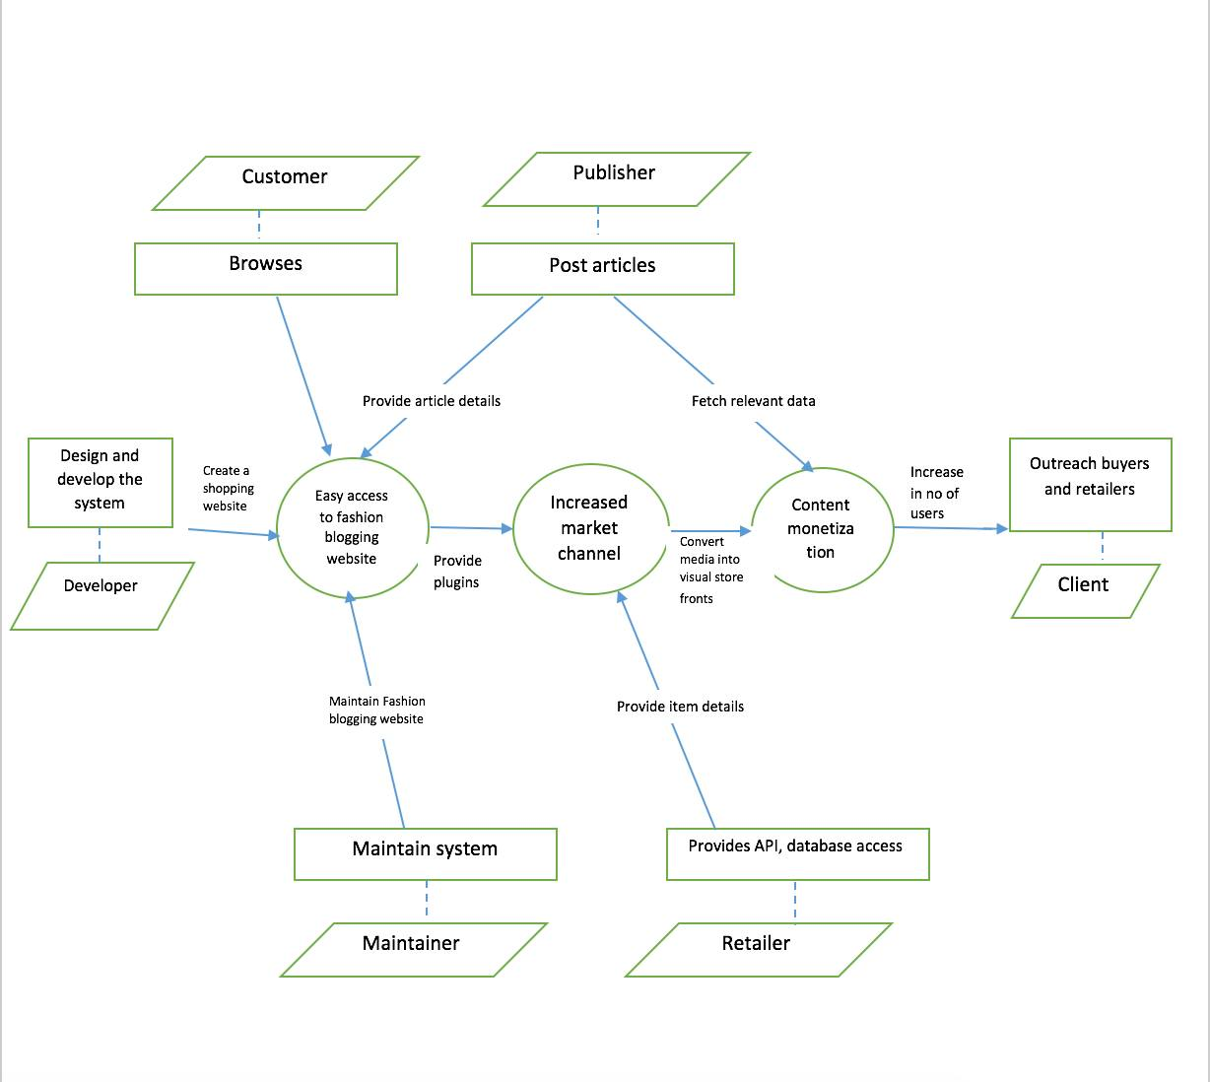

Figure 1: Benefit Chain Diagram

#### 

#### System Capability Description

The part of Frenzy Web application that needs to be designed, aims to make user experience robust and search results efficient. The application mainly targets people on the age range of 18-45. The two main functions are shop widgets and shop similar.

The first function will provide the user with an additional functionality of shop similar. It will also make amendments in the product slide view. It also aims to show sorting options on the top of the widget layer for better user experience.

The second function is to provide user with the ability to search large collection of products efficiently by sorting by prices (high to low and low to high), new arrivals, showing lower end products, showing product of the same brands and showing similar products (showing products of the same color id, category as the selected product). This function makes the search results relevant to the user’s liking.

#### System Boundary and Environment

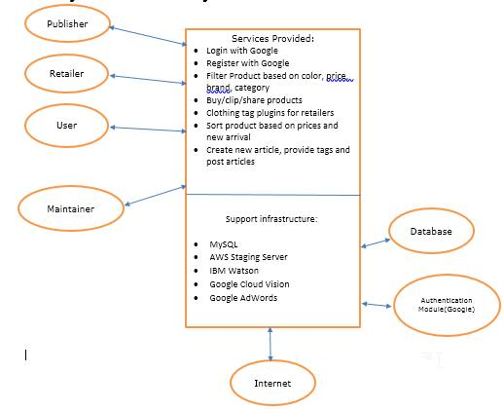**Figure 2: System Boundary & Environment Diagram**

### System Transformation

#### Information on Current System

##### Infrastructure

This is an existing web application built on the CodeIgniter framework. The application will be using AngularJS for redesigning the front end application.

##### Artifacts

The system has an existing work flow on which it is built.

|  |  |
| --- | --- |
| **Artifact** | **Description** |
| Use Case Diagrams | Describe the required features of the system |
| Robustness Diagrams | Detailed use cases and how they interact with the system classes. |
| Activity Diagrams | Defines the flow of a certain process |
| Design Document | The software description that is given to the development team. |
| Software Architecture | The structure of a software system. |
| Prototype | Created to avoid any system risks and defects |
| Data Model | The relationship between entities. |

##### Current Business Workflow



**Figure 3: Current Business Workflow**

#### System Objectives, Constraints and Priorities

##### Capability Goals

|  |  |
| --- | --- |
| **Capability Goals** | **Priority Level** |
| **OC-1 Sort Items: User can sort products based on prices, new arrival, most popular** | Must Have |
| **OC-2 Shop Widget: User can view the product in a slide view fashion and overall better UI** | Must Have |
| **OC-3 Shop similar: User can search similar items based on price, color, category and brand** | Must Have |
| **OC-4 Mobile Responsive: User can access frenzy web app through his mobile.** | Must Have |
| **OC-5 Elastic Search: Build a system to store the data in a search and analytics engine using AWS** | Wish List |

##### Level of Service Goals

To this point, we haven’t decided about any acceptable goals for the proposed new system's important levels of service.

##### Organizational Goals

Organizational goals are as follows:

**OG-1:** Automated Ecommerce of fashion blogging website.

**OG-2:** Using digital media as store fronts.

**OG-3:** Sort Products based on price, new arrival and most popular.

**OG-4:** Browse similar products based on color, style and price.

##### Constraints

Constraints are as follows:

**CO-1:** Use of Angular JS for front end development

**CO-2:** Use of Code Igniter Framework for backend

**CO-3:** Linux as an Operating System- The backend server is Linux

**CO-4:** Free Database System.

##### Relation to Current System

In information on current system, we mentioned that since we are building the system from scratch we studied Snapchat’s work flow as current system.

Table : Relation to Current System

|  |  |  |
| --- | --- | --- |
| **Capabilities** | **Current System** | **New System** |
| Roles and Responsibilities | * User can register and log in to the system using their google account * The user can follow the fashion blogger and articles present on the website * User can view the nearby stores. | * User can browse products and sort items based on style, color and price * User can see similar products present on the website |
| User Interactions | * Cannot search items using the search bar * Cannot log in through Facebook account * Cannot buy product without avoiding redirection to third party website. | * User can buy an item displayed on the articles page * User can share the items on other social networking sites * User can clip the items and add them to their account |
| Infrastructure | Web Application, MySQL database, server. | New mobile responsive website, server and database. |
| Stakeholder Essentials and Amenities | Easier way of shopping digital media | Easier way to search and shop the items |
| Future Capabilities | N/A | Providing automated commerce technology |

#### Proposed New Operational Concept

##### Element Relationship Diagram

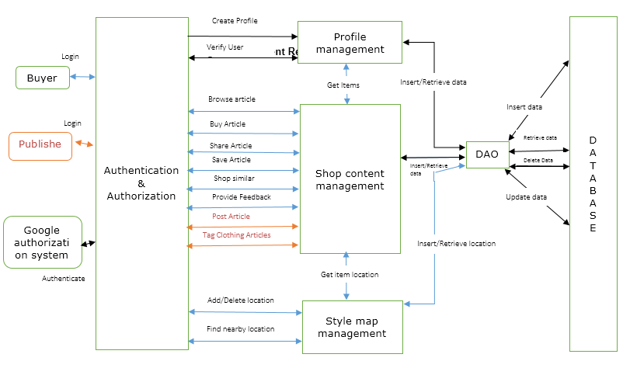

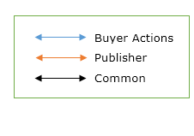

Figure 4: Element Relationship Diagram

##### Business Workflows

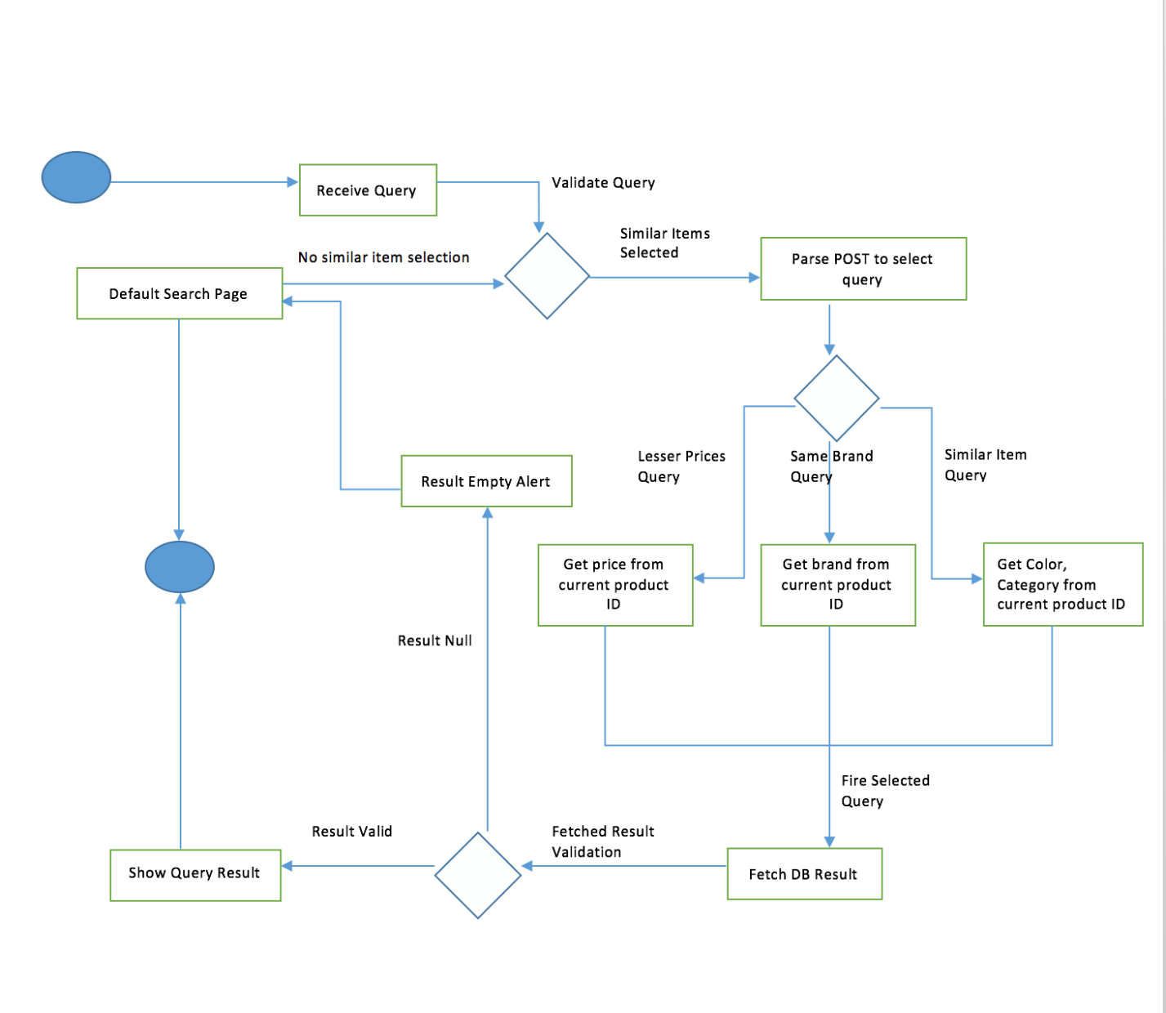

Figure 5: Business Workflows Diagram

#### Organizational and Operational Implications

##### Organizational Transformations

* The need to hire new developers to redesign the website.

##### Operational Transformations

* The user can buy, clip, share the product using the redesigned shop widget
* Similar products will be displayed using the shop similar functionality

